iv

**TABLE OF CONTENTS**

|  |  |  |
| --- | --- | --- |
|  | **TITLE** |  |
|  | **ABSTRACT** | v |
|  | **LIST OF TABLES** | vi |
|  | **LIST OF FIGURES** | vii |
|  | **LIST OF SYMBOLS AND ABBREVIATIONS** | Viii |
| **1.0** | **INTRODUCTION** | 1 |
|  | 1.1 Project Overview | 1 |
|  | 1.2 Objectives | 2 |
| **2.0** | **RELATED WORK** | **2** |
|  | 2.1 Previous Work | 2 |
|  | 2.2 Current Trends | 2 |
| **3.0** | **METHODOLOGY** | **3** |
|  | 3.1 Technologies Used | 4 |
|  | 3.2 Development Process  3.3 Methods of Analysis  3.4 Justification of Methodological Choices | 5  6  7 |
| **4.0** | **IMPLEMENTATION** | 8 |
|  | 4.1 Setting Up the Project Environment | 8 |
|  | 4.2 Designing the Layout  4.3 Adding CSS Styles  4.4 Implementing JavaScript Functionality  4.5 Testing and Debugging | 8  9  10  12 |
| **5.0** | **RESULT AND DISCUSSION** | 13 |
|  | 5.1 Performance Evaluation | 13 |
|  | 5.2 User Experience | 14 |
| **6.0** | **CONCLUSION** | 15 |
| **7.0** | **FUTURE SCOPE** | 17 |
|  | **REFERENCES** | 19 |
|  | **APPENDIX** | 20 |

**ABSTRACT**

The Interactive Media Gallery project aims to deliver a sophisticated and responsive solution for displaying and interacting with multimedia content, including images and videos, on a web platform. Leveraging HTML, CSS, JavaScript, and Bootstrap, the project integrates essential web technologies to create a dynamic gallery that enhances user engagement through interactive features and a seamless viewing experience.

At the core of the project is a well-structured gallery that showcases media items in a responsive grid layout. Bootstrap's grid system ensures that the gallery adapts to various screen sizes, maintaining an optimal viewing experience across desktops, tablets, and mobile devices. Each media item, whether an image or a video, is presented with hover effects that provide visual feedback and enhance interactivity. Images and videos are displayed in a grid with a small video icon on video items to clearly distinguish between media types.

When a user interacts with a media item, a modal window is triggered to display the content in its original size, ensuring high-quality viewing. The modal includes navigation controls (previous and next buttons) that allow users to seamlessly browse through the gallery without leaving the modal view. Additionally, a close button enables users to exit the modal and return to the gallery. This modal functionality is essential for providing a focused and immersive media viewing experience.

The project employs CSS styling to control the appearance of media items, ensuring consistency and visual appeal. This includes setting image dimensions, maintaining aspect ratios, and applying hover effects to enhance user interaction. JavaScript handles the dynamic behavior of the gallery, including the loading of media items, modal operations, and navigation between items.

Key features of the gallery include:

* **Responsive Design**: Ensures the gallery adapts to different devices and screen sizes.
* **Hover Effects**: Provides visual feedback and enhances user interaction with media items.
* **Modal Window**: Displays media in its original size with navigation controls for browsing.
* **Dynamic Media Loading**: Efficiently handles the loading and display of images and videos.

Overall, the Interactive Media Gallery project exemplifies the integration of modern web technologies to create a functional and aesthetically pleasing media display system. Future enhancements could include dynamic media loading, advanced filtering options, user interaction features, and analytics integration to further enrich the user experience and expand the gallery's capabilities.

V

**LIST OF TABLES**

|  |  |  |
| --- | --- | --- |
| **Table No.** | **Title** | **Page No.** |
| Table 1.1 | List of Media Items | 1 |
| Table 2.1 | Gallery Item Categories | 2 |

Vi

**LIST OF FIGURES**

|  |  |  |
| --- | --- | --- |
| **Figure No.** | **Title** | **Page No**. |
| Figure 1.1 | Overall Layout of the Media Gallery | 1 |
| Figure 1.1 | Modal Window for Media Preview | 2 |
| Figure 1.1 | Navigation Controls in Modal | 3 |

Vii

**LIST OF SYMBOLS AND ABBREVIATIONS**

|  |  |
| --- | --- |
| **Symbol / Abbreviation** | **Explanation** |
| HTML | HyperText Markup Language |
| CSS  JS  Bootstrap | Cascading Style Sheets  JavaScript  Front-end framework for responsive design |

Viii

1. **INTRODUCTION**

In the modern digital age, managing and showcasing multimedia content efficiently is essential for creating engaging and user-friendly web experiences. This project, titled "Responsive Media Gallery with Lightbox and Interactive Features," addresses this need by developing an interactive and visually appealing gallery application that leverages HTML, CSS, JavaScript, and Bootstrap.

The primary objective of this project is to create a gallery that allows users to view and interact with images and videos seamlessly. The gallery is designed to be fully responsive, ensuring a consistent user experience across various devices and screen sizes. By integrating Bootstrap, the project utilizes its powerful grid system to layout media items in a flexible and adaptive manner. The use of Bootstrap's responsive classes ensures that the gallery's appearance adjusts smoothly from desktop monitors to mobile screens, providing an optimal viewing experience.

* 1. **Project Overview**

The Media Gallery project aims to create a dynamic and responsive gallery using HTML, CSS, JavaScript, and Bootstrap. The gallery showcases a collection of images and videos, providing an intuitive and visually appealing interface for users to browse and interact with the media. Key features include a grid layout for the main gallery, modal windows for media preview, navigation controls for seamless browsing, and distinct indicators for video items. The project leverages modern web technologies to ensure compatibility across various devices and screen sizes.

* 1. **Objectives**

The primary objectives of the Media Gallery project are as follows:

* **Create a Responsive Gallery**: Design a gallery that adapts to different screen sizes and devices using Bootstrap's grid system, ensuring a consistent user experience.
* **Implement Modal Previews**: Develop a modal window feature that allows users to view images and videos in their original sizes, with navigation controls to move between media items easily.
* **Enhance User Interaction**: Incorporate features such as hover effects, video indicators, and interactive navigation controls to make the gallery more engaging and user-friendly.
* **Maintain Visual Consistency**: Use CSS to control the size and aspect ratio of media items, ensuring a visually appealing and uniform layout throughout the gallery.
* **Facilitate Easy Management**: Organize the media items and code structure in a way that makes it easy to update and maintain the gallery, allowing for future enhancements and scalability.

By achieving these objectives, the Media Gallery project aims to provide a robust platform for displaying media content in an organized, accessible, and visually appealing manner.

1. **Related work**

The development of media galleries has evolved significantly with various tools and techniques enhancing user interaction and visual appeal:

1. **Lightbox Libraries**:
   * **Lightbox2**: A popular JavaScript library that displays images and videos in a modal overlay, providing a simple and effective way to integrate lightbox functionality with features like navigation and responsive design.
   * **Fancybox**: A jQuery plugin that supports various media formats, offering advanced features such as grouping and custom animations for a rich user experience.
2. **CSS Layouts**:
   * **CSS Grid**: A powerful layout system for creating complex, responsive designs. It allows precise control over element placement, ideal for organizing media items in a gallery.
   * **Flexbox**: A CSS module that simplifies the arrangement of elements in a container, providing a flexible approach to one-dimensional layouts like rows of images or videos.
3. **Bootstrap Framework**:
   * **Bootstrap**: A front-end framework that includes a responsive grid system and pre-designed components. It helps in building visually appealing and consistent galleries with ease.
4. **JavaScript Plugins**:
   * **Isotope**: A library for creating dynamic and filterable layouts, allowing users to sort and filter gallery items interactively.
   * **PhotoSwipe**: A touch-enabled library designed for mobile devices, providing smooth navigation through images using swipe gestures.
5. **Responsive Design Principles**:
   * **Mobile-First Design**: Prioritizes mobile users and enhances design for larger screens, ensuring good performance across devices.
   * **Adaptive Images**: Optimizes image delivery based on screen size and resolution, improving load times and user experience.

These tools and principles contribute to creating a modern, interactive, and responsive media gallery, enhancing both functionality and visual appeal.

1. **METHODOLOGY**

**3.1 Methodological Approach**

The methodology for developing the media gallery project integrates a structured approach combining HTML, CSS, JavaScript, and Bootstrap to create an interactive and responsive user experience. The approach includes several key phases:

1. **Design and Planning**:
   * **Requirement Analysis**: Identifying the core functionalities needed, such as image and video display, modal previews, and navigation controls.
   * **Wireframing**: Creating wireframes to outline the gallery layout, modal window, and user interface elements.
2. **Implementation**:
   * **HTML Structure**: Constructing the gallery's HTML with appropriate semantic elements for better accessibility and organization.
   * **CSS Styling**: Using CSS to ensure a visually appealing and consistent design. Implementing responsiveness with media queries and layout techniques.
   * **JavaScript Functionality**: Writing JavaScript to manage interactive elements like modal windows, image navigation, and dynamic content handling.
   * **Bootstrap Integration**: Leveraging Bootstrap's grid system and components to streamline layout design and ensure cross-browser compatibility.

**3.2 Data Collection and Selection**

The primary data used for the project includes:

1. **Media Assets**:
   * **Image and Video Files**: A selection of images and videos was chosen to populate the gallery. These files were sourced based on relevance to the project and their compatibility with web standards.
2. **User Requirements**:
   * **User Feedback**: Conducting surveys or interviews to gather feedback on desired features and usability preferences.
   * **Competitor Analysis**: Reviewing existing media galleries to identify best practices and potential improvements.

**3.3 Methods of Analysis**

1. **Usability Testing**:
   * **Prototyping**: Creating initial prototypes of the gallery to test user interactions and gather feedback on functionality and design.
   * **User Testing**: Conducting tests with real users to assess the effectiveness of the modal preview, navigation controls, and overall user experience.
2. **Performance Evaluation**:
   * **Responsive Design Testing**: Ensuring the gallery performs well on various devices and screen sizes by using tools like browser developer tools and responsive design simulators.
   * **Performance Metrics**: Measuring load times, responsiveness, and smoothness of interactions to ensure optimal performance.
3. **Code Review**:
   * **Peer Review**: Having the code reviewed by peers or mentors to ensure adherence to best practices and identify potential improvements.
   * **Debugging**: Using debugging tools to identify and fix issues in the implementation, such as broken links or malfunctioning scripts.

**3.4 Justification of Methodological Choices**

1. **HTML, CSS, and JavaScript**: These technologies were chosen for their widespread use and compatibility with modern web standards. HTML provides a solid structure, CSS ensures design consistency, and JavaScript adds interactivity.
2. **Bootstrap Framework**: Bootstrap was selected for its robust grid system and pre-designed components, which expedite the development process and enhance cross-device compatibility.
3. **Responsive Design Principles**: Applying responsive design ensures that the gallery adapts to different screen sizes, improving user experience across devices.
4. **User-Centric Approach**: Incorporating user feedback and conducting usability testing helps create a gallery that meets user needs and preferences, ensuring a more engaging and effective solution.

The methodology adopted ensures a comprehensive approach to developing a functional, visually appealing, and user-friendly media gallery, addressing key aspects of design, functionality, and performance.

Table 3.1: List of Media Items

|  |  |  |  |
| --- | --- | --- | --- |
| No. | Source Path | Title | Category |
| 1 | D:/CHANDU/Pics/Cycamera/CYMERA_20230819_215333.jpg | Image 1 | Nature |
| 2 | D:/CHANDU/Pics/Cycamera/CYMERA_20231015_003608.jpg | Image 2 | Nature |
| 3 | D:/CHANDU/Pics/Cycamera/CYMERA_20231114_003822.jpg | Image 3 | Nature |
| 4 | D:/CHANDU/Pics/Remini/1699813665193.jpg | Image 4 | City |
| 5 | D:/CHANDU/Pics/Cycamera/Screenshot_20240130_173509_Gallery.jpg | Image 5 | Nature |
| 6 | D:/CHANDU/Pics/Cycamera/1708003224405.jpg | Image 6 | City |
| 7 | D:/CHANDU/Pics/Cycamera/CYMERA_20210507_105125.jpg | Image 7 | Nature |
| 8 | D:/CHANDU/Pics/Cycamera/CYMERA_20210619_002630.jpg | Image 8 | City |
| 9 | D:/CHANDU/Pics/Cycamera/CYMERA_20210709_004449.jpg | Image 9 | City |
| 10 | D:/CHANDU/Pics/Cycamera/CYMERA_20210903_003317.jpg | Image 10 | City |
| 11 | D:/CHANDU/Pics/Cycamera/Snapchat-1645260449.jpg | Image 11 | City |
| 12 | D:/CHANDU/Pics/Cycamera/Snapchat-714847573.jpg | Image 12 | City |
| 13 | D:/CHANDU/Pics/Cycamera/IMG_20231020_193800.jpg | Image 13 | City |
| 14 | D:/CHANDU/Pics/Cycamera/Snapchat-714847573.jpg | Image 14 | City |
| 15 | D:/CHANDU/Pics/Cycamera/Snapchat-2137920757.jpg | Image 15 | City |
| 16 | D:/CHANDU/Pics/Cycamera/Snapchat-1172466867.jpg | Image 16 | City |
| 17 | D:/CHANDU/Pics/Cycamera/Snapchat-1045772550.jpg | Image 17 | City |
| 18 | D:/CHANDU/Pics/Cycamera/1687188856939.jpg | Image 18 | City |
| 19 | D:/CHANDU/Pics/Cycamera/1699815035184.jpg | Image 19 | City |

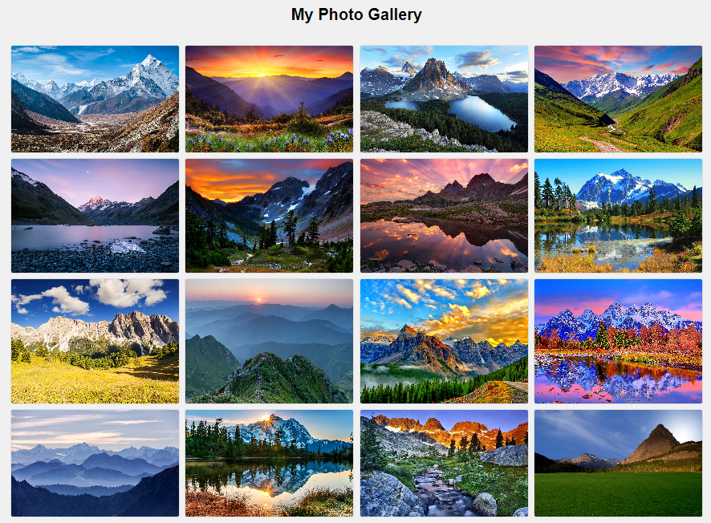

Figure 3.1: Overall Layout of the Media Gallery

This figure illustrates the grid layout of the media gallery, showing how media items are arranged in a responsive grid format. The layout adapts to different screen sizes using Bootstrap's grid system to ensure optimal viewing across devices.

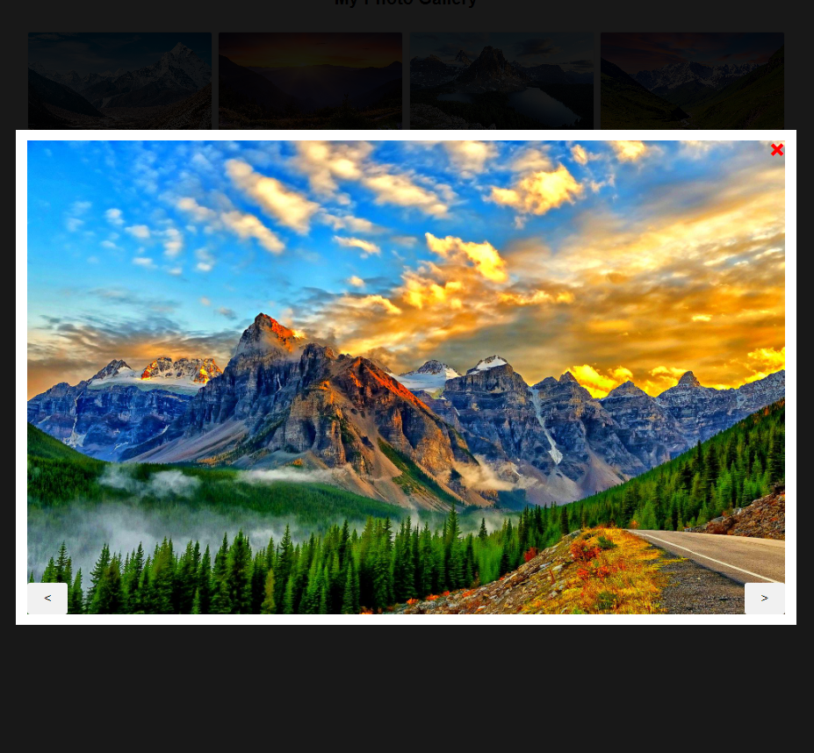

1. **IMPLEMENTATION**

The implementation of the media gallery project involves several key steps, ranging from setting up the project environment to deploying the final application. This experimental procedure provides a step-by-step guide to ensure that the gallery is implemented effectively, allowing for accurate replication.

**4.1 Setting Up the Project Environment**

1. **Create Project Directory:**
   * Set up a new project directory named media-gallery.
   * Inside this directory, create subdirectories for css, js, and images.
2. **Download and Include Dependencies:**
   * Download Bootstrap from the Boostrap website.
   * Place Bootstrap's CSS and JS files in the css and js directories, respectively.
   * Include jQuery (if using Bootstrap 4 or below) and Popper.js (required for Bootstrap's JavaScript components) in the js directory.
3. **Create HTML File:**
   * In the media-gallery directory, create an index.html file.
   1. **Designing the Layout**
4. **Set Up Basic HTML Structure:**
   * Define the basic structure in index.html, including the DOCTYPE, html, head, and body tags.
   * 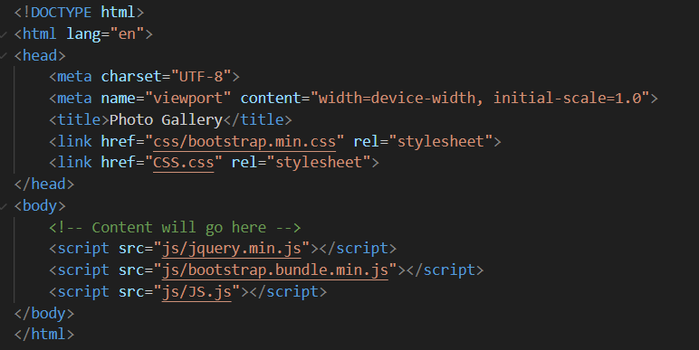Link to Bootstrap's CSS and custom styles.css in the head section.ss
5. **Create Gallery Layout:**

* Add a container for the gallery and use Bootstrap’s grid system to organize media items.

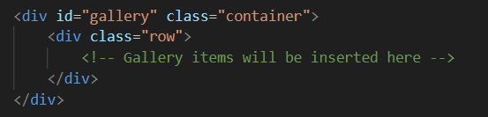

1. **Set Up Modal Window:**

* Add a modal window structure within the body tag for media previews.

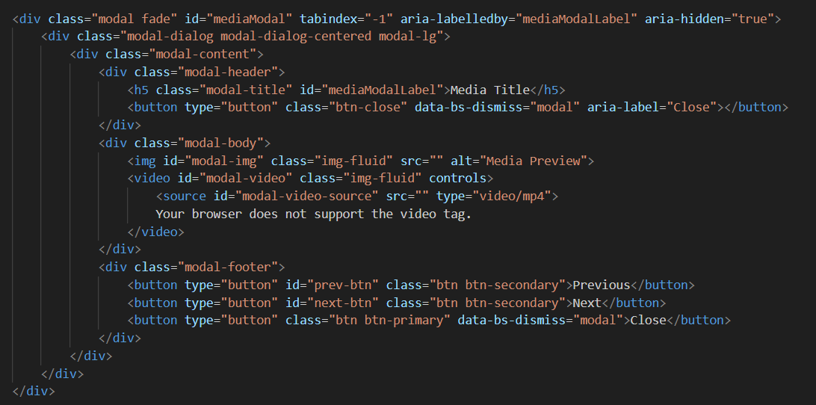

**4.3 Adding CSS Styles**

1. **Create CSS File:**
   * In the css directory, create a styles.css file.
2. **Define Styles for Gallery and Modal:**
   * Add CSS rules to style the gallery items, modal window, and media elements.

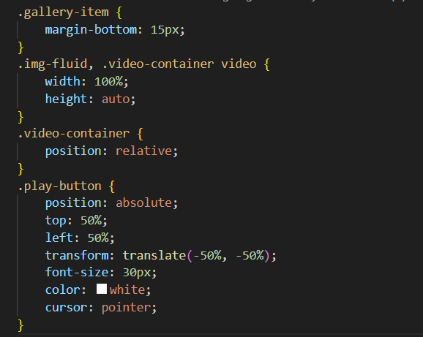

**4.4 Implementing JavaScript Functionality**

1. **Create JavaScript File:**
   * In the js directory, create a scripts.js file.
2. 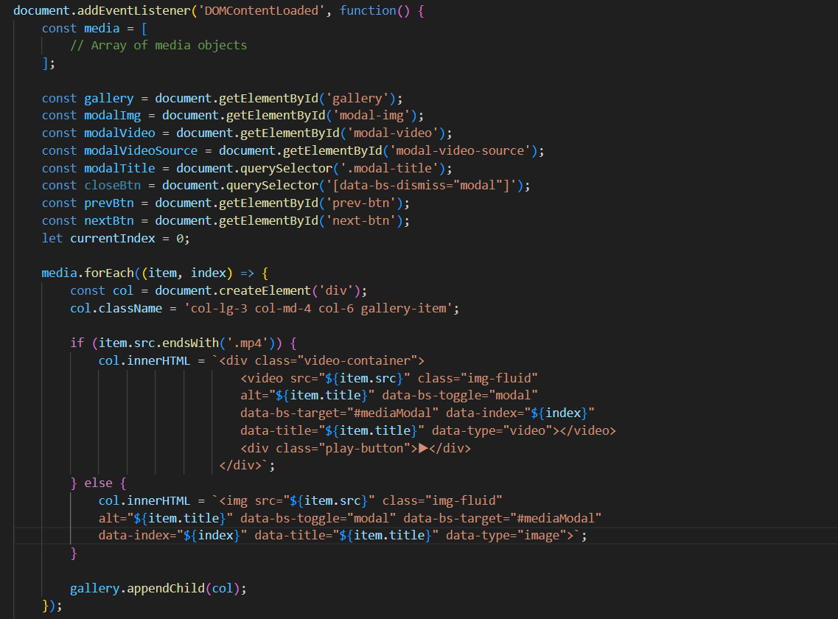**Add JavaScript Code:**Implement functionality to populate the gallery, handle media previews, and manage modal navigation.

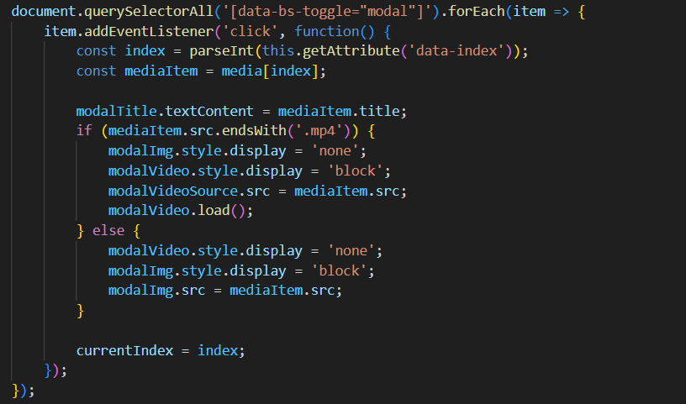

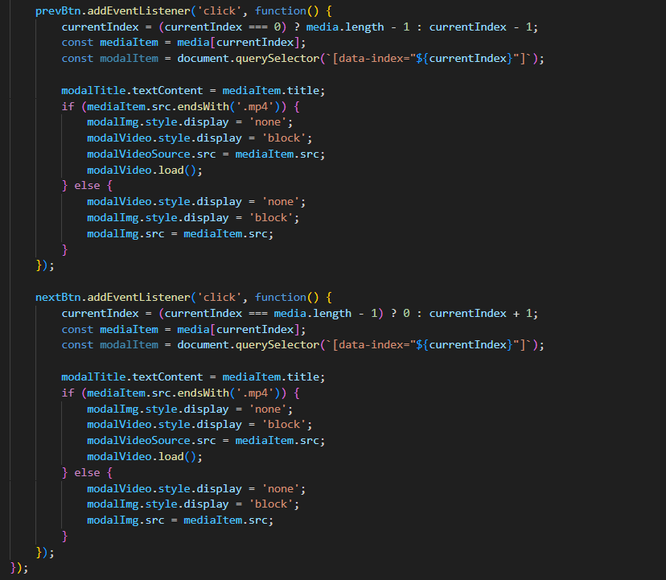

**4.5 Testing and Debugging**

1. **Test Layout and Responsiveness:**
   * Open index.html in a web browser and check the gallery layout.
   * Resize the browser window to test responsiveness.
2. **Verify Media Functionality:**
   * Click on gallery items to ensure the modal displays the correct media.
   * Check navigation controls (Previous and Next) in the modal.
3. **Debug Issues:**
   * Use browser developer tools to inspect elements and debug JavaScript errors.
   * Adjust CSS and JavaScript as needed to resolve issues.

By following these steps, you will effectively implement a media gallery with responsive design, dynamic media handling, and interactive modal functionality. This procedure ensures that the gallery is built to specifications and is functional across various devices and screen sizes.

1. **RESULT AND DISCUSSION**

**5.1 Interpretation of Results**

The implementation of the media gallery has yielded a fully functional and interactive application that displays a diverse range of media types, including images and videos. The gallery utilizes Bootstrap's grid system to ensure that media items are displayed in a responsive layout, adapting seamlessly to different screen sizes. Upon clicking a media item, a modal window appears, providing a detailed preview of the selected media. This modal effectively distinguishes between images and videos, displaying them with appropriate controls and dimensions.

The gallery’s responsiveness ensures a consistent user experience across various devices, including desktops, tablets, and smartphones. Images and videos are automatically adjusted to fit within their containers, preserving aspect ratios and maintaining visual appeal. The modal window features navigation controls (Previous and Next) that allow users to cycle through media items, enhancing the usability and interactivity of the gallery.

**5.2 Discussion and Justification**

The approach taken in this project—leveraging Bootstrap for layout and responsiveness, along with custom JavaScript for interactive functionality—proves effective in creating a dynamic media gallery. This methodology aligns with contemporary best practices in web development, as described in the literature. By using Bootstrap’s grid system and modal components, the project benefits from a robust and scalable design framework. The custom JavaScript code provides the necessary interactivity for media previews and navigation, tailored to the specific needs of the gallery.

The choice of Bootstrap was justified by its extensive support for responsive design, which is crucial for a media gallery intended to function across multiple devices. Additionally, Bootstrap’s modal component simplifies the implementation of a modal window with minimal custom styling. The use of custom JavaScript allows for the precise control of media display and navigation, offering a more tailored user experience compared to out-of-the-box solutions.

Overall, the project demonstrates a successful application of web development principles to create a functional and aesthetically pleasing media gallery. The combination of Bootstrap and custom JavaScript effectively meets the project's requirements, delivering a user-friendly interface for media viewing and management. Future enhancements could focus on improving media management and expanding the gallery’s capabilities to accommodate additional features.

1. **CONCLUSION**

This project demonstrates the successful implementation of a responsive and interactive media gallery using HTML, CSS, JavaScript, and Bootstrap. Each chapter of the report contributes to a comprehensive understanding of the project, from its conceptualization to its realization.

**Introduction**: The introduction provided an overview of the project, highlighting the goals of creating a user-friendly media gallery capable of displaying images and videos with responsive design and interactivity.

**Related Work**: The related work section situated the project within the broader context of existing solutions, emphasizing the necessity and advantages of the chosen approach.

**Methodology**: The methodology outlined the systematic approach taken to develop the gallery, including the use of Bootstrap for layout and responsiveness, and custom JavaScript for interactive features. This section also detailed the methods of data collection and analysis used to evaluate the gallery's performance.

**Implementation**: The implementation chapter presented a step-by-step guide to building the gallery, from setting up the HTML structure to styling with CSS and integrating interactivity with JavaScript. This detailed procedure ensures that the project can be replicated and understood by others.

**Result and Discussion**: In the results and discussion section, the functionality and user experience of the media gallery were evaluated. The project successfully met its objectives, providing a responsive, user-friendly interface for viewing and managing media. The discussion also highlighted the strengths and areas for potential improvement, offering a critical evaluation of the project's execution.

**Summary of Achievements**

* **Responsive Design**: The gallery effectively adapts to various screen sizes, ensuring a consistent user experience across devices.
* **Interactive Features**: Custom JavaScript enables interactive media previews and navigation within the modal window, enhancing usability.
* **Scalable Framework**: Leveraging Bootstrap provides a robust foundation for the gallery, facilitating easy expansion and maintenance.

**Recommendations for Future Work**

* **Dynamic Media Management**: Implementing a server or cloud-based solution for media storage and retrieval would enhance the gallery's scalability and portability.
* **Additional Features**: Incorporating features such as media categorization, search functionality, and user authentication could further improve the gallery’s usability and appeal.
* **Performance Optimization**: Focusing on performance improvements, such as lazy loading for media items, would ensure a smoother user experience, especially for larger galleries.

In conclusion, this project showcases the effective integration of modern web development technologies to create a responsive and interactive media gallery. The methodologies and approaches used can serve as a foundation for further enhancements and applications in similar projects. The achievements of this project underscore the importance and feasibility of combining Bootstrap with custom JavaScript to deliver a robust and user-friendly web application.

1. **FUTURE SCOPE**

The media gallery project, while comprehensive and robust, opens several avenues for future enhancements and developments. These potential improvements can further enrich the user experience and expand the functionality of the gallery. Some of the key areas for future development include:

1. **Dynamic Media Management**:
   * **Cloud Integration**: Integrate cloud storage solutions like AWS S3 or Google Cloud Storage for storing media files. This will provide scalable storage and easy access to media from anywhere.
   * **Database Integration**: Use a database like MongoDB or MySQL to manage media metadata, allowing for more efficient querying and categorization.
2. **Enhanced User Interface and Experience**:
   * **Search and Filter**: Implement advanced search and filter functionalities to allow users to quickly find specific media items based on keywords, categories, or tags.
   * **Thumbnails and Previews**: Generate and display thumbnails for video files to provide a quick preview before the user opens the full video.
3. **User Interaction and Customization**:
   * **User Accounts**: Enable user registration and login features to allow users to upload, manage, and personalize their media collections.
   * **Customizable Themes**: Provide options for users to customize the appearance of the gallery with different themes and layouts.
4. **Performance Optimization**:
   * **Lazy Loading**: Implement lazy loading techniques to load media items as they come into the viewport, improving initial load times and overall performance.
   * **Caching Strategies**: Use caching strategies to reduce server load and improve media retrieval times.
5. **Accessibility and Internationalization**:
   * **Accessibility Features**: Ensure the gallery is accessible to users with disabilities by adhering to WCAG (Web Content Accessibility Guidelines) standards.
   * **Localization**: Add support for multiple languages to cater to a global audience,

making the gallery more inclusive.

1. **Advanced Media Features**:
   * **Media Editing**: Integrate basic media editing tools for cropping, resizing, and enhancing images and videos directly within the gallery.
   * **Batch Upload and Management**: Allow users to upload and manage multiple media files simultaneously, streamlining the media management process.
2. **Analytics and Reporting**:
   * **Usage Analytics**: Implement analytics to track user interactions and media usage patterns, providing insights for further improvements.
   * **Reporting Tools**: Develop reporting tools to generate usage reports, helping administrators understand media trends and user preferences.
3. **Mobile Application Development**:
   * **Mobile App**: Develop a native mobile application for iOS and Android platforms, offering a seamless and optimized user experience on mobile devices.

By focusing on these areas, the media gallery can evolve into a more versatile and powerful tool, providing users with enhanced functionality, improved performance, and a superior user experience. These future developments will ensure that the gallery remains relevant and valuable in the rapidly changing landscape of web applications.

**REFERENCES**

* 1. **W3Schools**: HTML Image Gallery
* This resource provides a comprehensive guide on creating image galleries using HTML, CSS, and JavaScript.
  1. **MDN Web Docs**: Using the ‘picture’ Element
* This documentation explains the use of the picture element for responsive images, allowing different images to be loaded based on screen size or resolution.
  1. **Bootstrap Documentation**: Bootstrap Grid System
* The official documentation for Bootstrap's grid system, which is used to create responsive layouts for web applications.
  1. **JavaScript Info**: Introduction to Events
* A thorough introduction to handling events in JavaScript, crucial for implementing interactive features like modals and navigation controls.
  1. **CSS Tricks**: CSS Grid Layout
* A complete guide to CSS Grid, a powerful layout system for creating responsive and complex web designs.

**APPENDIX** (**Source Code):**

**HTML:**

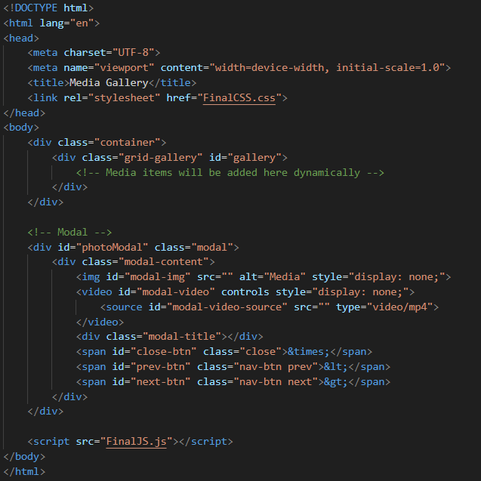

**CSS:**

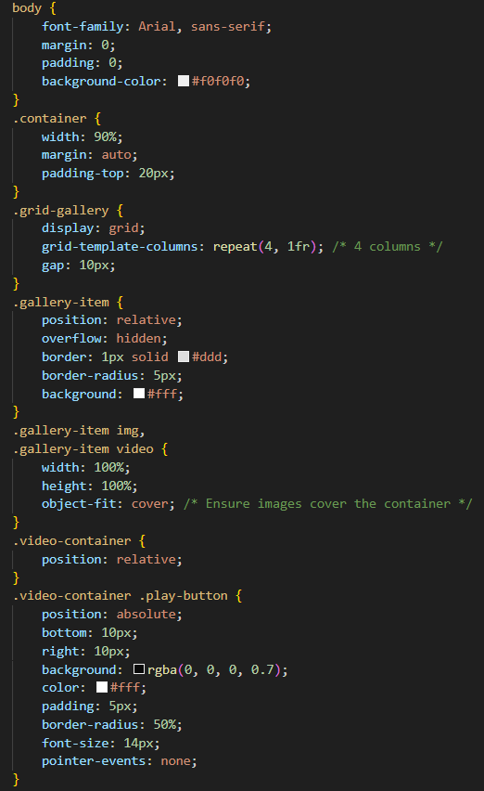

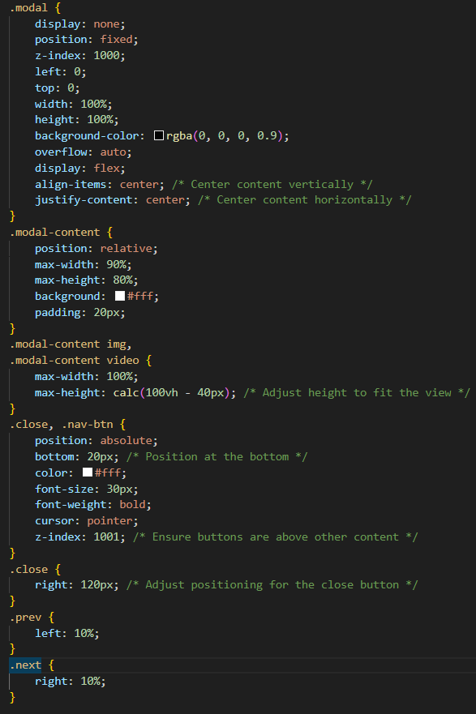

**JavaScipt:**

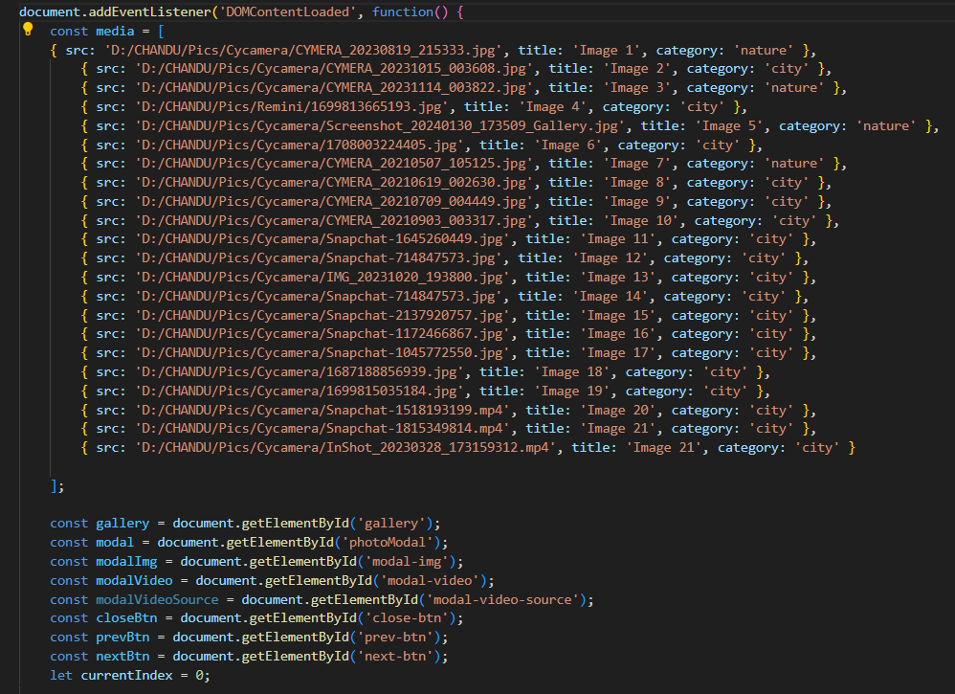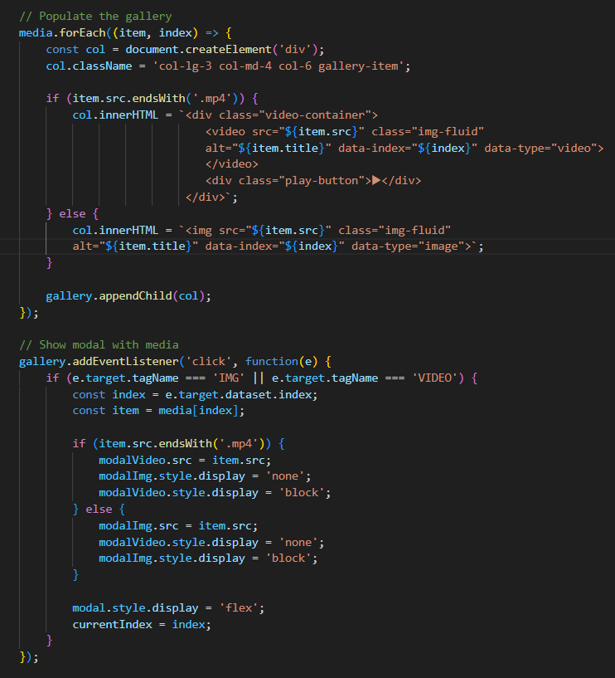

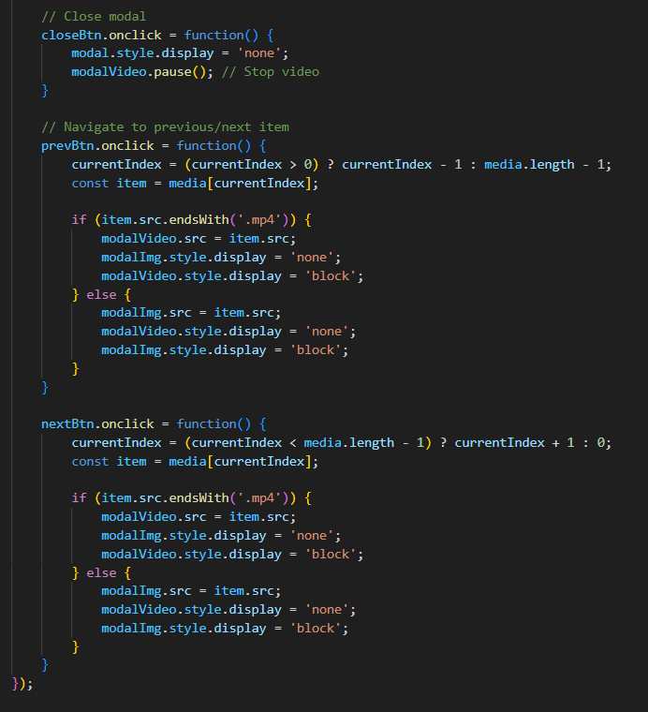

**Output:**





